API Screenshots from Postman and MongoDB

1. User Registration:

Endpoint: /api/users/register

Method: POST

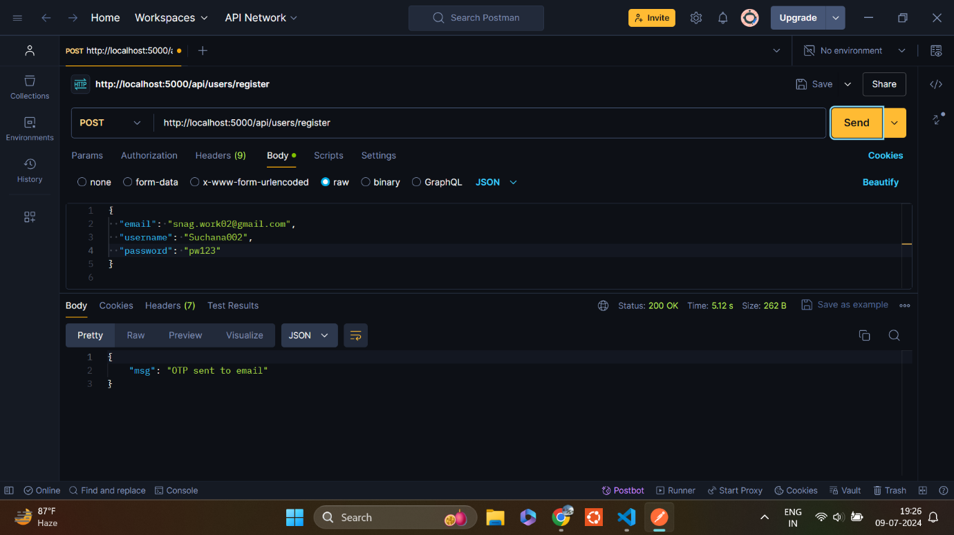Description: Registers a new user

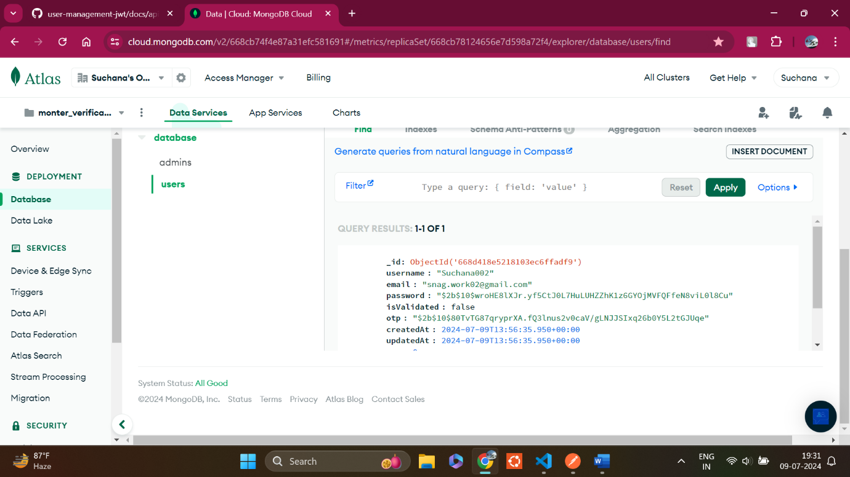

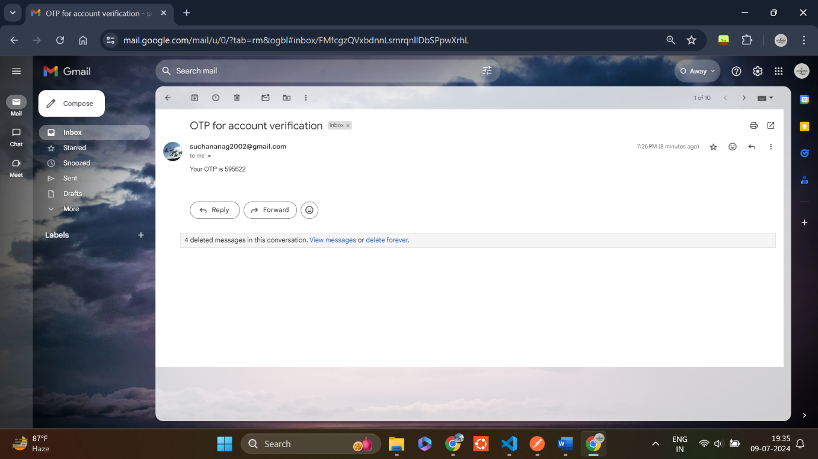

1. User OTP Verification:

Endpoint: /api/users/verify-otp

Method: POST

Description: Verify the otp sent to the user’s email

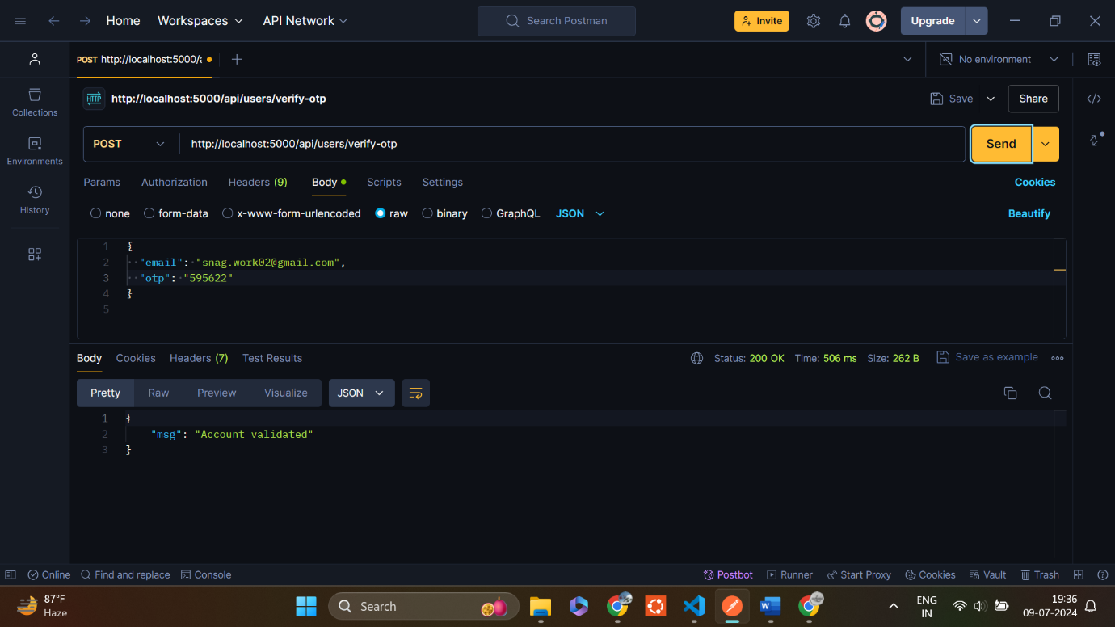

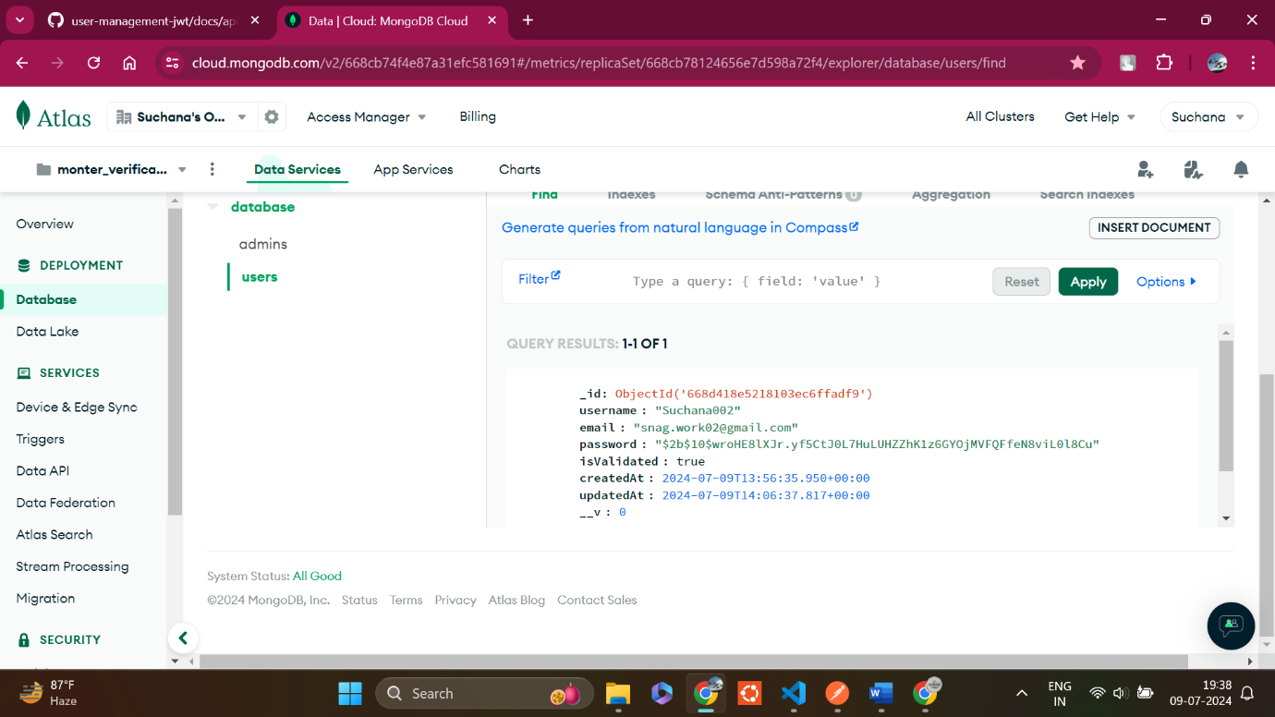

1. Add User Information:

Endpoint: /api/users/add-info

Method: POST

Description: Add additional information after account validation

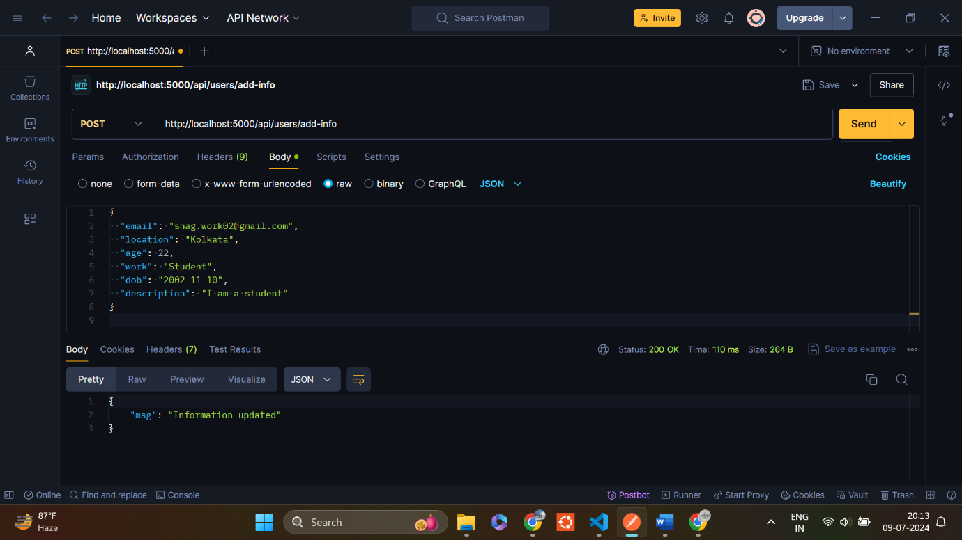

1. 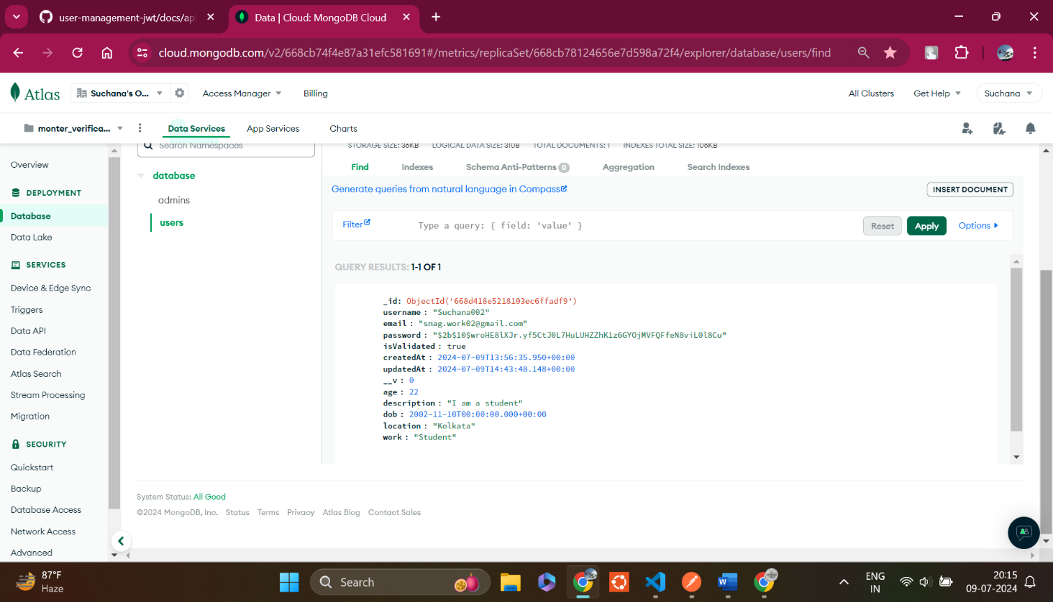User login:

Endpoint: /api/users/login

Method: POST

Description: Login a user and generate a JWT token

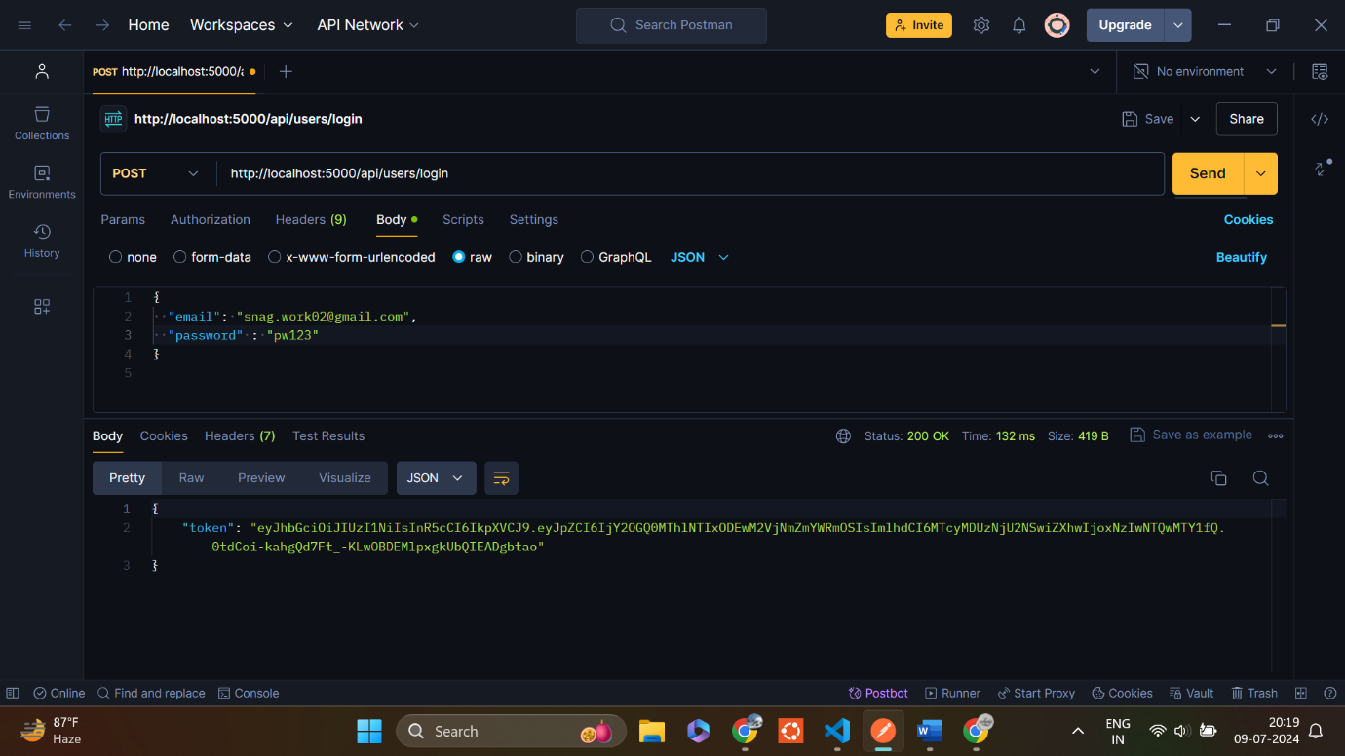

1. Get user information:

Endpoint: /api/users/login

Method: POST

Description: Login a user and generate a JWT token

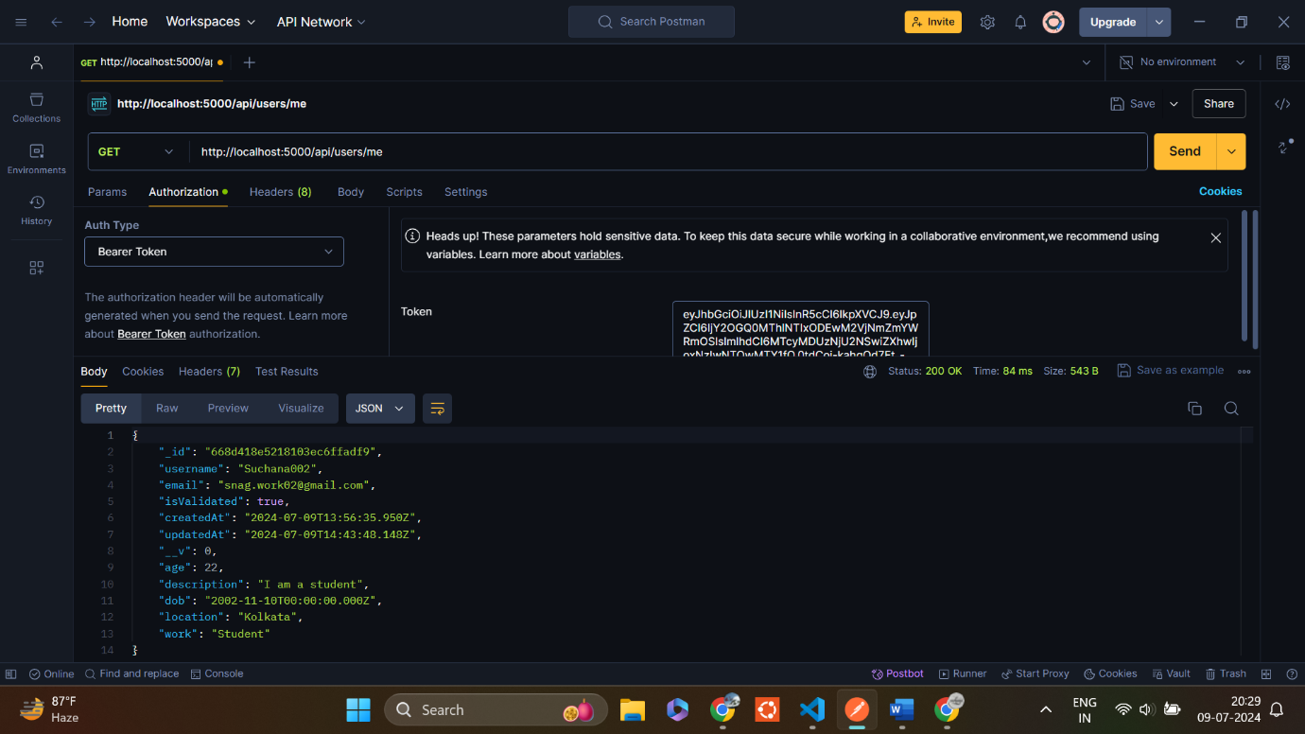

1. Update user information:

Endpoint: /api/users/update-info

Method: PUT

Description: Update the logged in user’s information using the JWT token

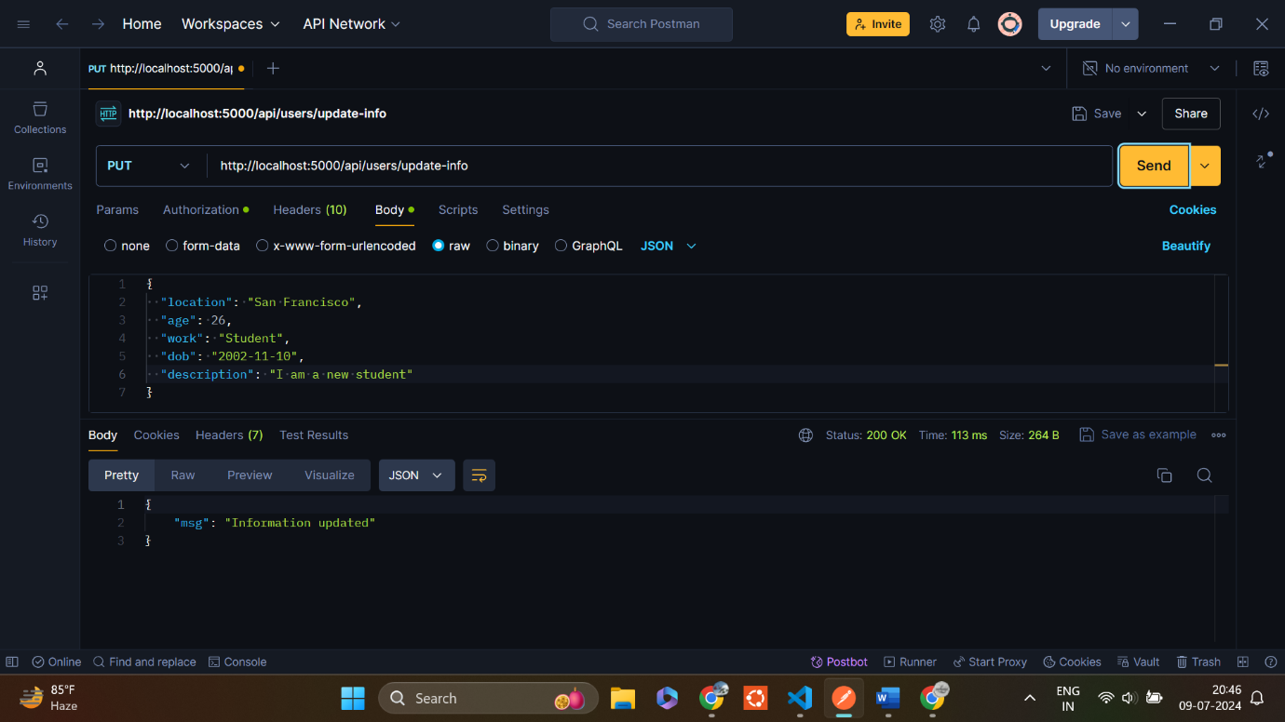

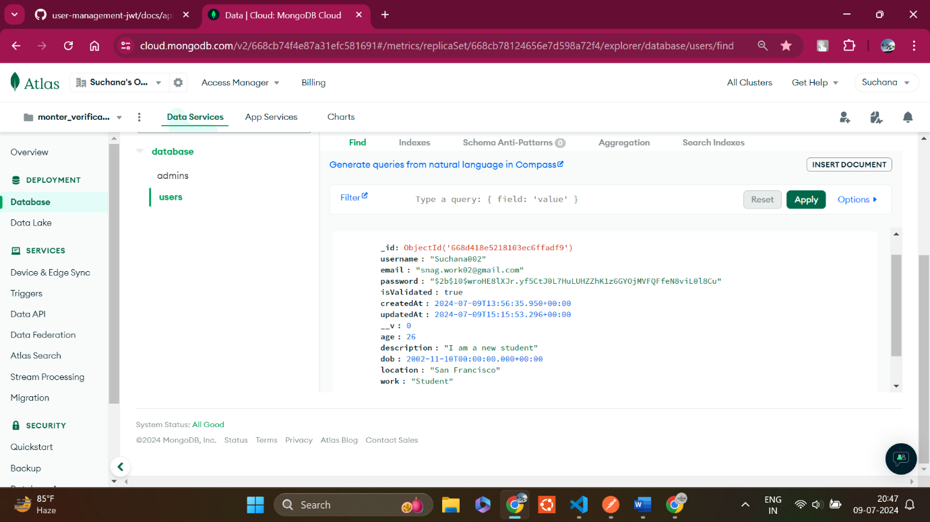

1. Admin Registration:

Endpoint: /api/admin/register

Method: POST

Description: Register a new admin

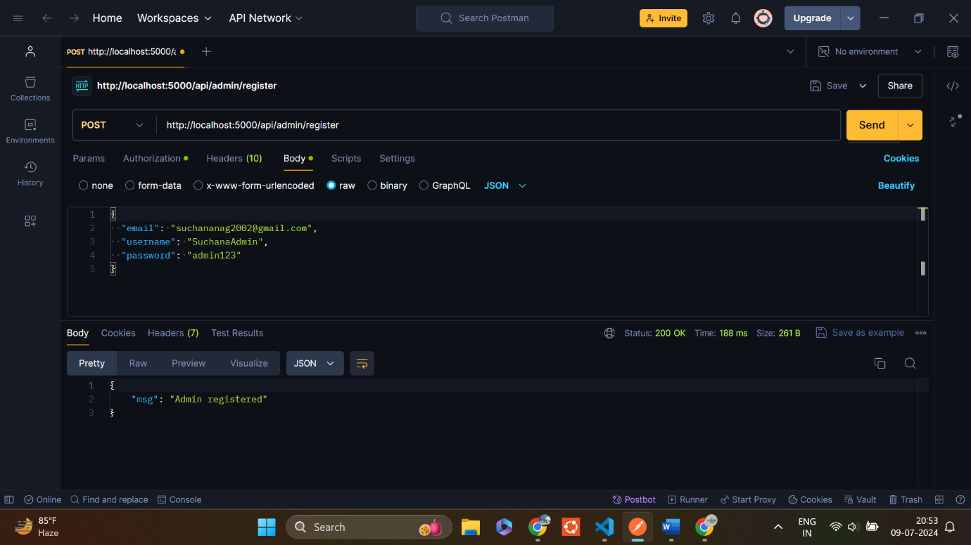

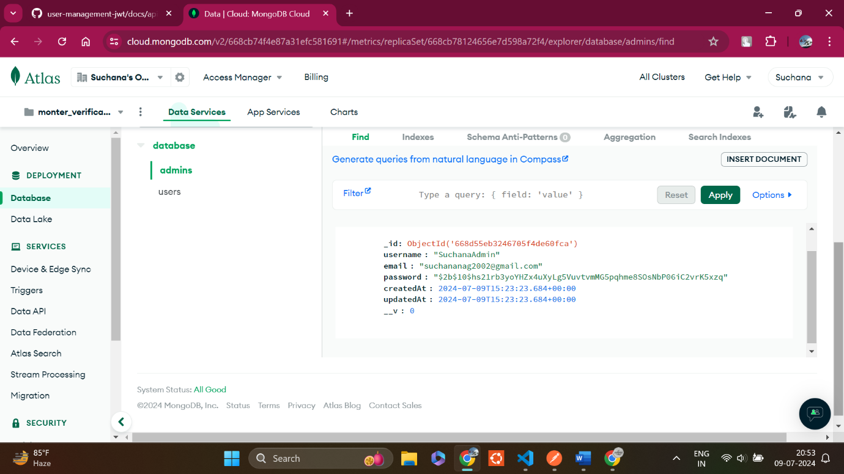

1. Admin login:

Endpoint: /api/admin/login

Method: POST

Description: Login an admin and generate a JWT token

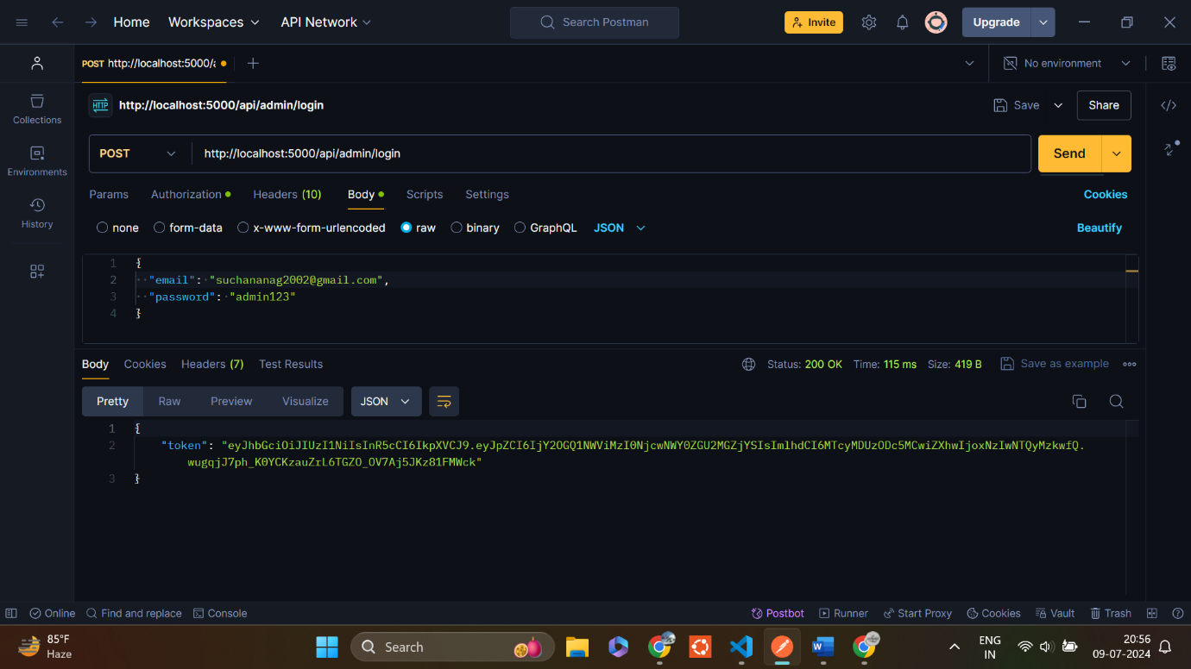

1. View all users by admin:

Endpoint: /api/admin/users

Method: GET

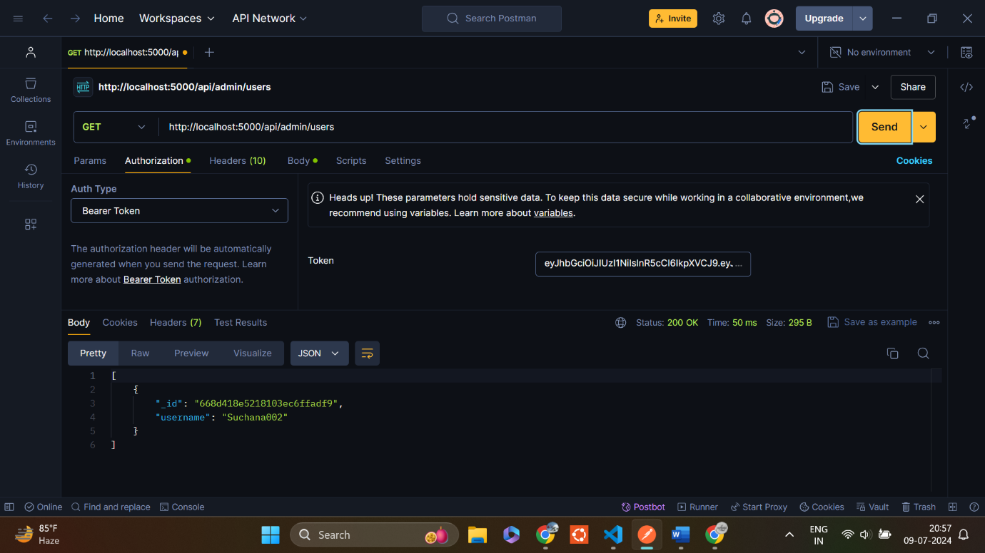Description: Get all details of a user by username

1. Delete a user by admin:

Endpoint: /api/admin/users/:username

Method: DELETE

Description: Delete a user by username

